StickMatch
Game Design Document
[Ver. 0.0.1 ]
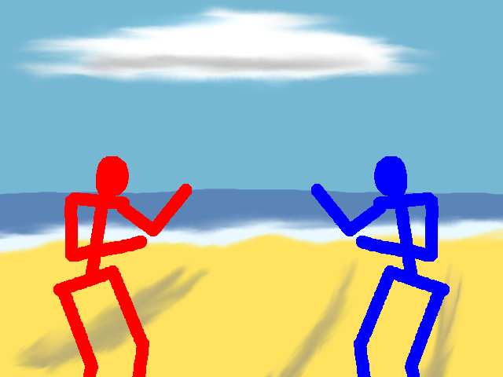
02/04/2012

Interactive Laboratories

Version History

Version | Comments | Author
0.0.1 | Initial draft | Stuart Cassidy

Table of Contents
Executive Summary 4
Overview 4
Verse 4
Plot Graphs 5
Singleplayer Gameplay 5
Wide-Area-Network/Local-Area-Network Gameplay 6
Controls 7
Level Design 9
Beach 9
Dojo 9
Cityscape 10
Colosseum 10
Mechanics 11
Technology Plan 11

Executive Summary

Cross-platform, multiplayer, networked, 3D fighting game. Runs across Xbox, Windows, and Linux [Ver. 1.0]. Will appeal to a wide audience by being non-realistic so we can even get parents to buy it for their one-year-old!

Overview

StickMatch is a competitive 3D fighting game. There is no story, there is no objective. The only thing you can do in the game is fight against either an AI or a human opponent. A scoreboard is maintained, anyone can enter their three initials to claim victory at the top. Players can compete against each other over a local non-networked game, a local-area networked game, or a wide-area networked game on the Xbox, Windows, and Linux platforms. The game is a one or two player affair. No teams on each side, just one fighter against another.

Visually, the game isn't going for realism, nor is it aiming to be non-photo realistic. Opponents are simple stick figures that punch, kick, throw, and guard to survive and become the best fighter they can. Games can have matches with rounds ranging from one to 10. Rules are set on the machine the host player is occupying.

Players have the chance to break another player's ligaments if enough damage is inflicted, which will force players to become more strategic in their matches. Plus, it will just make for an interesting, if somewhat difficult, mechanic. This can be toggled on or off depending on the player's preferences.

While the game is 3D in graphics, it is also 3D in terms of movement. The primary way to move in and out of the screen is to do so with the same key, button, or analogue axis as you would for jumping and crouching. Jumping and crouching are achieved by using a modifier in conjunction with the move in/out input method.

Both stick fighters have the same set of abilities. They can both jump, crouch, punch, kick, guard, throw, and move left/right/in/out. Combinations of these different maneuvers can be used to perform various actions.

Verse

In the world of StickMatch, a generic reason for a tournament being held every day is applied. Fighters are virtual opponents which fight until they either break or their life gauge depletes. When a fighter expires, a new one is created to replace it. The matches are broadcast to the masses as cheap entertainment while they whittle away their existence in this realm. Fighters are created from all manner of objects, from wooden sticks, to reinforcing bars. They are animated by methods unknown. All of them are prone to breakage at one stage or another.

Players construct their fighters to take part in these tournaments to achieve some kind of primal victory over their mark.

Plot Graphs

Singleplayer Gameplay

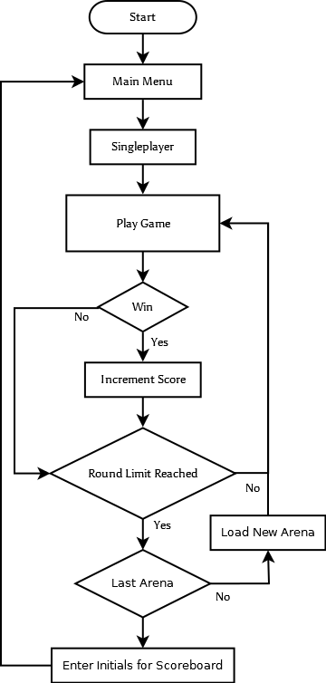

Singleplayer mode gives the player an arena to practice in. There will be a set of arenas for the player to advance forward.

Wide-Area-Network/Local-Area-Network Gameplay

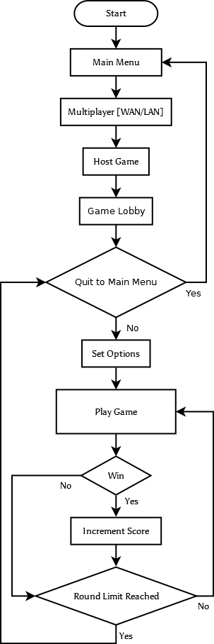

Multiplayer games over a network connection are almost the same as a local, singleplayer game, except that only one arena at a time is played, then when the match is over the players are kicked back to the lobby.

Controls

Xbox Controller

Input | Action [Menus] | Action [In-Game]
A | Select/Confirm | Guard
B | Back/Cancel | Kick
X |  | Punch
Y |  | Grab
Start | Select/Confirm | Pause/Unpause
Back | Back/Cancel
White
Black
Left Trigger |  | Movement Modifier
Right Trigger
Left Analogue Stick | Up/Down Move Up/Down One Item | Move Around Arena
Right Analogue Stick
Left Analogue Stick Button
Right Analogue Stick Button
D-Pad Up | Move Up One Item | Move Into Screen
D-Pad Down | Move Down One Item | Move Out of Screen
D-Pad Left |  | Move to the Left
D-Pad Right |  | Move to the Right

Xbox 360 Controller

Input | Action [Menus] | Action [In-Game]
A | Select/Confirm | Guard
B | Back/Cancel | Kick
X |  | Punch
Y |  | Grab
Start | Select/Confirm | Pause/Unpause
Back | Back/Cancel
Left Bumper
Right Bumper
Left Trigger |  | Movement Modifier
Right Trigger
Left Analogue Stick | Up/Down Move Up/Down One Item | Move Around Arena
Right Analogue Stick
Left Analogue Stick Button
Right Analogue Stick Button
D-Pad Up | Move Up One Item | Move Into Screen
D-Pad Down | Move Down One Item | Move Out of Screen
D-Pad Left |  | Move to the Left
D-Pad Right |  | Move to the Right

Keyboard

Input | Action [Menus] | Action [In-Game]
M | Select/Confirm | Guard
K | Back/Cancel | Kick
J |  | Punch
N |  | Grab
Enter | Select/Confirm | Pause/Unpause
Backspace | Back/Cancel
Shift |  | Movement Modifier
W/Up | Move Up One Item | Move Into Screen
S/Down | Move Down One Item | Move Out of Screen
A/Left |  | Move to the Left
D/Right |  | Move to the Right

Level Design

Depending on the time of day and weather setting, all levels will be a variation on the base configuration. Set pieces will frequent arenas. Detached limbs can be replaced by these different items scattered around and used as weapons.

Beach
Description
Typical coastal affair. Sand, sea, and rocks. Players can move pretty freely in this arena. Barricades come in the form of stacked up beach deck chairs and rocks near the land. Shark nets contain the players in the sea. Though, not all of the sharks.

Set Pieces
Parasols

Per-Arena Resources
Models
  - Parasol
  - Beach deck chair
  - Rocks
  - Sharks
Shaders
  - Water
Audio
  - Seagulls cawing

<<Beach images need to be produced>>

Dojo
Description
Japanese-style Dojo. Not much freedom as it's a small arena.

Set Pieces
Torches, scrolls, and wooden weapons.

Per-Arena Resources
Models

<<Dojo images need to be produced>>

Cityscape
Description
Depending on the time of day and the weather, there may or may not be pedestrians wandering around this skyscraper forest. When there are pedestrians, they will be getting out of the way when they observe you and your opponent barrelling toward them in fisticuffs. Blocking player movement indefinitely is provided by road blocks for maintenance work. Buildings cannot be entered and are only there for eye-candy. The road you fight on is very wide so that there is enough room to compete in.

Set Pieces
Traffic cones and cable for maintenance can be used as weapons.

Per-Arena Resources
- Buildings
- Pedestrians
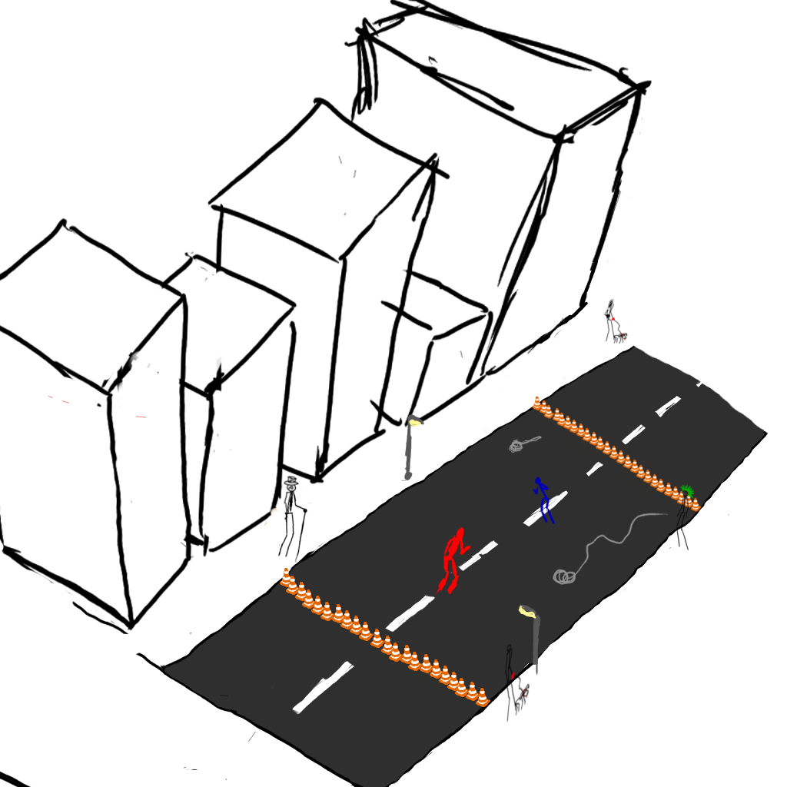

Colosseum
Description
Barren and not a whole lot of anything to get in the way of you and your opponent. Spectators will be at the arena during the day and fewer will frequent at night. When spectators are in attendance, they will throw various weaponry down to the combatants for kicks.

Set Pieces
No set pieces are present in the arena. Spectators will throw weapons down to combatants.

Per-Arena Resources

<<Colosseum images need to be produced>>

Mechanics

Fighting

Technology Plan

Software
Programming
GCC 4.6 [Linux]
Visual Studio 2003 [Windows 2000-XP and Xbox]
Visual Studio 2010 [Windows Vista and Newer]
Art
Blender
GIMP
Inkscape
Debugging
gDEBugger
AMD CodeAnalyst
Documentation
LibreOffice Writer
Zim
Dia
Doxygen
Project Management
IN EVALUATION
Asset Management
Mercurial

Hardware
PC
Graphics Cards
Audio Cards
Processors
Motherboards
Hard Disc Drives
Network Interface Cards
Optical Drives
Floppy Drives
Memory

Console

